ECEN 301

Student_____________________________________ Sec_____

Electrical Engineering for Engineers
Brigham Young University

Lab 7: Schmitt Trigger using LF347
And Potentiometers
1.
2.
3.

PURPOSE
The purpose of this lab is to demonstrate the functionality of a Schmitt trigger using potentiometers to adjust trigger levels.

OBJECTIVES
- Learn and demonstrate the use of potentiometers
- Learn and demonstrate design and use of a Schmitt trigger and adjusting switching levels.
- Discuss the differences between a Schmitt Trigger and a comparator.
- Use a Schmitt Trigger to generate a clock signal from a sin wave.

Pre-lab Work
-Review Schmitt triggers and comparators from your notes and text.
Procedure

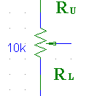
- Potentiometers
Potentiometers, also known as Pots, are variable resistors that can be tuned to acquire the resistance that is needed. The potentiometer shown (see right) has a total resistance of 10kΩ and the wiper (the arrow that points to the middle of the resistor) is what changes the resistances of both sides. In essence, it creates a variable voltage divider that is tunable by the user. Using your knowledge of voltage division calculate the values of R_{U} and R_{L} in the schematic below for a specific output voltage
.
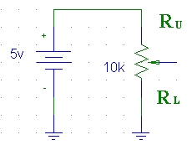
Remember: R_{U} + R_{L} = 10k.
Vout = Vin*R_{L}/ R_{U} + R_{L}

Table 1. R_{U} and R_{L}
Input V | Output V | R_{U} | R_{L}
5V | 4.5V
5V | 2.5V
5V | 1.5V

Once you have computed the values of R_{U} and R_{L} you will now construct the schematic on your breadboard and measure the output voltages using the values of R_{U} and R_{L} in Table 1. Orient your potentiometer as shown in the schematic below. Use the fixed 5v DC from the power supply as your voltage source. Do not connect the power supply until you have already adjusted the values of R_{U} and R_{L} on your potentiometer. You will not be able to measure the resistances when the power is applied. When measuring the resistances of R_{U} and R_{L} on the pot, measure the resistance across the R_{U} pin and the wiper for R_{U} and across the wiper and R_{L} for R_{L}.
Once you have the pot hooked up to the Digital Multimeter you can adjust the resistance by turning the white knob on top of the Pot. Fully counter clockwise will set R_{U} to 10KΩ and R_{L} to 0Ω. Fully clockwise will set R_{U} to 0Ω and R_{L} to10kΩ.

Once you have the potentiometer set to the values in Table 1, you can apply the 5v DC supply to the circuit and measure the output across the wiper and ground. Record your measurements in Table 2.

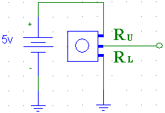
Table 2. (use R_{U} and R_{L} from Table 1.)
R_{U} | R_{L} | Measured Output V

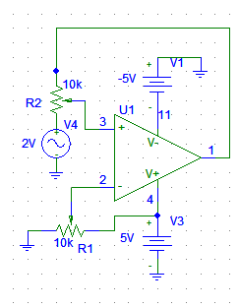

- Schmitt Trigger
With your understanding of potentiometers you will now make a variable Schmitt trigger. Using the potentiometers we are going to change the trigger levels of the Schmitt trigger which will create an alternating high and low signal.
4V p/p

1. Construct the Schmitt trigger circuit (as seen to the right) using two 10K potentiometers and an LF347 Op-amp. (see schematic at the end of the lab to see the potentiometer orientation). Do not connect the circuit to the power yet.

2. We want to set the trigger level to 1V (R1). In order to do this we must set the voltage at the inverting input to 1V. This is where the potentiometer comes into play.
R1 is the pot that will help us set the inverting input voltage to 1V. As shown below, R1 creates a circuit similar to the one in the above portion of this lab. Use the techniques of part one to find out the values of R_{U} + R_{L} to produce 1V at the negative terminal.

Table 3: P1 values.
R_{U}
R_{L}

3. Once you have the values for R1, use your DMM to set R1s values in your circuit.
4. Now we want to set the non-inverting input (R2) voltage to 0V (turn the pot to give the Max INPUT signal). Use the same method to find out the values of R_{U} + R_{L} to produce 0V at the non-inverting input. You can check the voltages with the DMM.

5. You have not set your Schmitt trigger to trigger when your input reaches 1V.

6. Hook up your circuit to the power supply with a +5 and -5 for the Op-amp and set your input signal to: 4Vpp @ 1kHz sine wave. You can leave the F.G. in High Z.
Using the O-scope, measure the input and output of the Schmitt trigger and draw what you see in the space below. Note: put both the input and output on the same axis to see
what happens when the input voltage hits 1 V.

Show the waves from the O-Scope to a Ta to make sure they are correct before continuing.

Input and Output when set at 1V.

7. Now, change the amplitude on the function generator and record the corresponding +Duty cycle for each voltage level in Table 4.

Why does the Duty cycle increase or decrease with different voltage levels?

Table 4. Duty Cycle
Vin | Duty cycle
1.5V P/P
2.5V P/P
3V P/P
4V P/P

8. What happens to the output voltage? Explain.

What happens to the output voltage when P1 is turned clockwise? Explain.

Demonstrate your working Schmitt trigger to a TA to pass off.

Conclusion
State what you learned in the lab and give a brief summary of how changing P1 affected the output voltage. Also, list some applications where a Schmitt trigger may be useful.

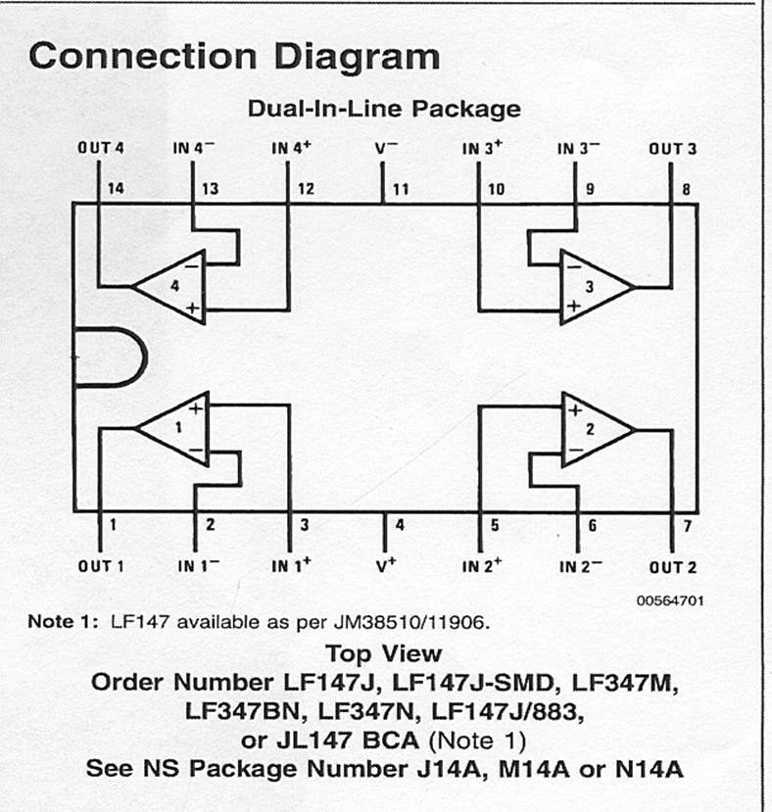

4V P/P

